

Semester Two Examination, 2018

Question/Answer booklet

MATHEMATICS

SOLUTIONS
SPECIALIST
UNITS 1 AND 2

Section One:

Calculator-free

Student number: In figures

In words

Your name

Time allowed for this section
Reading time before commencing work: five minutes
Working time: fifty minutes

Materials required/recommended for this section
To be provided by the supervisor
This Question/Answer booklet
Formula sheet

To be provided by the candidate
Standard items: pens (blue/black preferred), pencils (including coloured), sharpener,
correction fluid/tape, eraser, ruler, highlighters

Special items: nil

Important note to candidates
No other items may be taken into the examination room. It is your responsibility to ensure that you do not have any unauthorised material. If you have any unauthorised material with you, hand it to the supervisor before reading any further.

Structure of this paper

Section | Number of questions available | Number of questions to be answered | Working  time (minutes) | Marks available | Percentage of examination
Section One:  Calculator-free | 8 | 8 | 50 | 52 | 35
Section Two:  Calculator-assumed | 13 | 13 | 100 | 98 | 65
 |  |  |  | Total | 100

Instructions to candidates

1. The rules for the conduct of examinations are detailed in the school handbook. Sitting this examination implies that you agree to abide by these rules.

2. Write your answers in this Question/Answer booklet.

3. You must be careful to confine your response to the specific question asked and to follow any instructions that are specified to a particular question.

4. Supplementary pages for the use of planning/continuing your answer to a question
have been provided at the end of this Question/Answer booklet. If you use these pages to continue an answer, indicate at the original answer where the answer is continued, i.e. give the page number.

5. Show all your working clearly. Your working should be in sufficient detail to allow your answers to be checked readily and for marks to be awarded for reasoning. Incorrect answers given without supporting reasoning cannot be allocated any marks. For any question or part question worth more than two marks, valid working or justification is required to receive full marks. If you repeat any question, ensure that you cancel the answer you do not wish to have marked.

6. It is recommended that you do not use pencil, except in diagrams.

7. The Formula sheet is not to be handed in with your Question/Answer booklet.

Section One: Calculator-free 35% (52 Marks)
This section has eight (8) questions. Answer all questions. Write your answers in the spaces provided.

Working time: 50 minutes.

Question 1 (7 marks)
Let $A=\left[\begin{matrix}2 & -1 \\ -3 & 0\end{matrix}\right]$ and $B=\left[\begin{matrix}5 & 4 \\ 7 & 6\end{matrix}\right]$.

Determine

(a) $AA^{-1}$. (1 mark)
Solution
$$AA^{-1}=I=\left[\begin{matrix}1 & 0 \\ 0 & 1\end{matrix}\right]$$

Specific behaviours
identity matrix

(b) $2A+B$. (2 marks)
Solution
$$2×\left[\begin{matrix}2 & -1 \\ -3 & 0\end{matrix}\right]+\left[\begin{matrix}5 & 4 \\ 7 & 6\end{matrix}\right]=\left[\begin{matrix}4 & -2 \\ -6 & 0\end{matrix}\right]+\left[\begin{matrix}5 & 4 \\ 7 & 6\end{matrix}\right]=\left[\begin{matrix}9 & 2 \\ 1 & 6\end{matrix}\right]$$

Specific behaviours
multiple of $A$
✓ correct sum

(c) $AB$. (2 marks)
Solution
$$\left[\begin{matrix}2 & -1 \\ -3 & 0\end{matrix}\right]\left[\begin{matrix}5 & 4 \\ 7 & 6\end{matrix}\right]=\left[\begin{matrix}3 & 2 \\ -15 & -12\end{matrix}\right]$$

Specific behaviours
at least two correct elements
✓ correct product

(d) $B^{-1}$. (2 marks)
Solution
$${\left[\begin{matrix}5 & 4 \\ 7 & 6\end{matrix}\right]}^{-1}=\frac{1}{30-28}×\left[\begin{matrix}6 & -4 \\ -7 & 5\end{matrix}\right]=\left[\begin{matrix}3 & -2 \\ -3.5 & 2.5\end{matrix}\right]$$

Specific behaviours
indicates determinant
✓ correct inverse

Question 2 (4 marks)
$z_{1}$ and $z_{2}$ are the complex solutions to the equation $z^{2}-2z+10=0$.

The location of $z_{1}$ is shown in the complex plane below.

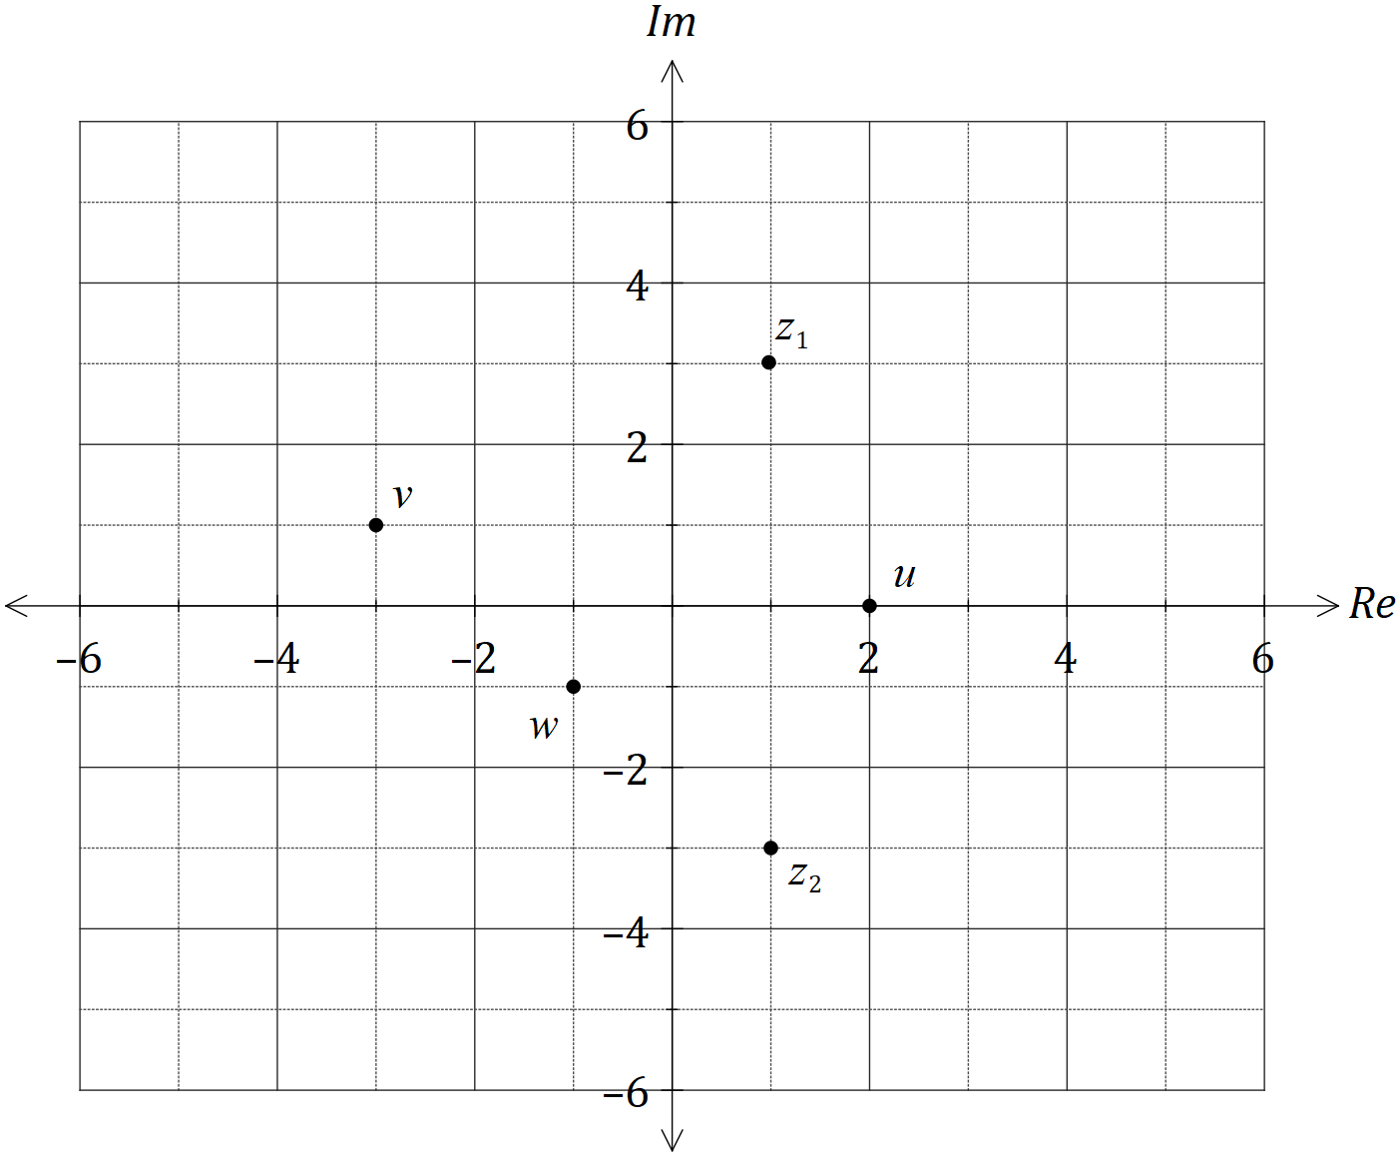

Add, with a label, the following complex numbers to the complex plane above.
Solution
$$z_{2}=\overline{z_{1}}=1-3i \\ u=2 \\ v=i\left(1+3i\right)=-3+i \\ w=\overline{-1+i}=-1-i$$

Specific behaviours
plots $z_{2}$
✓ plots $u$
✓ plots $v$
✓ plots $w$

(a) $z_{2}$. (1 mark)

(b) $u=z_{1}+z_{2}$. (1 mark)

(c) $v=iz_{1}$. (1 mark)

(d) $w=\overline{u+v}$. (1 mark)

Question 3 (6 marks)
(a) Draw a neat diagram to illustrate the angle in the alternate segment theorem. (2 marks)
Solution
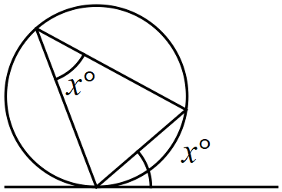

Specific behaviours
diagram correctly shows circle, tangent and triangle
✓ clearly marks angles that are equal

(b) Consider the statement 'if a pentagon is regular, then it has sides of equal length'.

(i) Write the inverse of the statement. (1 mark)
Solution
If a pentagon is not regular, then it does not have sides of equal length.

Specific behaviours
changes $P⇒Q$ to $\overline{P}⇒\overline{Q}$

(ii) Write the contrapositive of the statement. (1 mark)
Solution
If a pentagon does not have sides of equal length, then it is not regular.

Specific behaviours
changes $P⇒Q$ to $\overline{Q}⇒\overline{P}$

(iii) Write the converse of the statement and neatly sketch a counter-example to show that the converse is not true. (2 marks)
Solution
If a pentagon has sides of equal length, then it is regular.

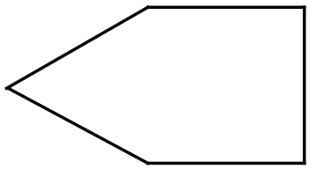

Specific behaviours
reverses $P⇒Q$ to $Q⇒P$
✓ diagram shows irregular pentagon with equal sides

Question 4 (8 marks)
(a) On the axes below, sketch the graphs of $y=\tan\left(\begin{matrix}x \\ \overline{2}\end{matrix}\right)$ and $y=\cot\left(\begin{matrix}x \\ \overline{2}\end{matrix}\right)$, where $0≤x≤360°$, labelling all asymptotes. Note that $\tan{76°}≈4$. (5 marks)

Solution
See graph
Specific behaviours
✓ tan graph through $A, B, D, E$
asymptote for tan graph
✓ cot graph through $B, C, D$
✓ two asymptotes for cot graph
✓ accurately uses $\tan{76°}≈4$ for both
NB solution assumes cot=cos/sin, not 1/tan

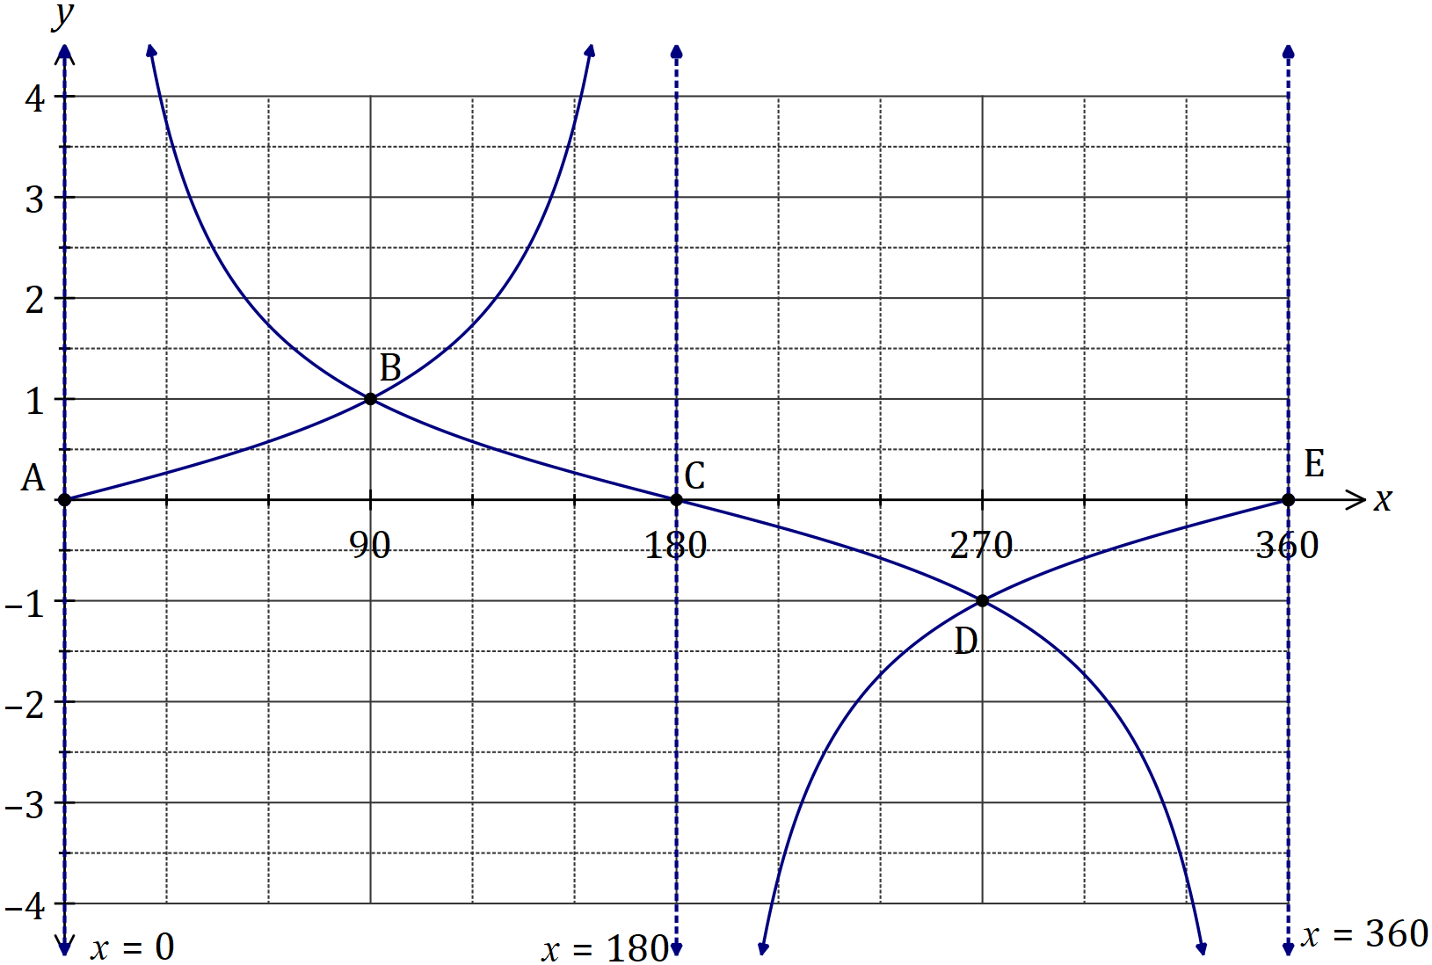

(b) Solve the equation $\sec^{2}{(x)}=3\tan^{2}{(x)}-1$ over the interval $0≤x≤360°$. (3 marks)
Solution
$$1+\tan^{2}{(x)}=3\tan^{2}{(x)}-1$$

$$\tan^{2}\left(x\right)=1$$
$$\tan{x}=±1$$

$$x=45°, 135°, 225°, 315°$$

Specific behaviours
uses Pythagorean identity
✓ correct values for $\tan{x}$
✓ correct solutions

Question 5 (6 marks)
The position vectors of points $P$ and $Q$ are $p=\left[\begin{matrix}3 \\ 1\end{matrix}\right]$ and $q=\left[\begin{matrix}1 \\ -1\end{matrix}\right]$ respectively.

(a) Determine the magnitude of the displacement vector $\vec{PQ}$. (2 marks)
Solution
$$\vec{PQ}=\left[\begin{matrix}1 \\ -1\end{matrix}\right]-\left[\begin{matrix}3 \\ 1\end{matrix}\right]=\left[\begin{matrix}-2 \\ -2\end{matrix}\right]$$

$$\left|\vec{PQ}\right|=2\sqrt{2}$$

Specific behaviours
correct $\vec{PQ}$
✓ correct magnitude

(b) Determine the values of $λ$ so that $\left|p-λq\right|=4$. (4 marks)
Solution
$$p-λq=\left[\begin{matrix}3-λ \\ 1+λ\end{matrix}\right]$$

$$∴{\left(3- λ\right)}^{2}+{\left(1+λ\right)}^{2}=16$$

$$λ^{2}-6λ+9+λ^{2}+2λ+1=16$$
$$2λ^{2}-4λ-6=0$$
$$λ^{2}-2λ-3=0$$
$$\left(λ+1\right)\left(λ-3\right)=0$$

$$λ=-1, λ=3$$

Specific behaviours
expression for vector in terms of $λ$
✓ equation for magnitude of vector
✓ simplifies and factorises equation
✓ states both values for $λ$

Question 6 (8 marks)
Let $f\left(x\right)=2\sin{x}+2\cos{x}$.

(a) Express $f(x)$ in the form $r\sin\left(x+α\right)$ where $0<α<\frac{π}{2}$. (4 marks)
Solution
$$r=\sqrt{2^{2}+2^{2}}=2\sqrt{2}$$

$$\sin\left(x+α\right)=\frac{2}{2\sqrt{2}}\sin{x}+\frac{2}{2\sqrt{2}}\cos{x} \\ =\sin{x}\cos{α}+\cos{x}\sin{α}$$
$$∴\cos{α}=\frac{2}{2\sqrt{2}}=\frac{1}{\sqrt{2}}, \sin{α}=\frac{2}{2\sqrt{2}}=\frac{1}{\sqrt{2}}⇒α=\frac{π}{4}$$

$$f\left(x\right)=2\sqrt{2}\sin\left(x+\frac{π}{4}\right)$$

Specific behaviours
value of $r$
✓ values of $\sin{α}$ and $\cos{α}$
✓ value of $α$
✓ expression for $f(x)$

(b) Sketch the graph of $y=f(x)$. (4 marks)

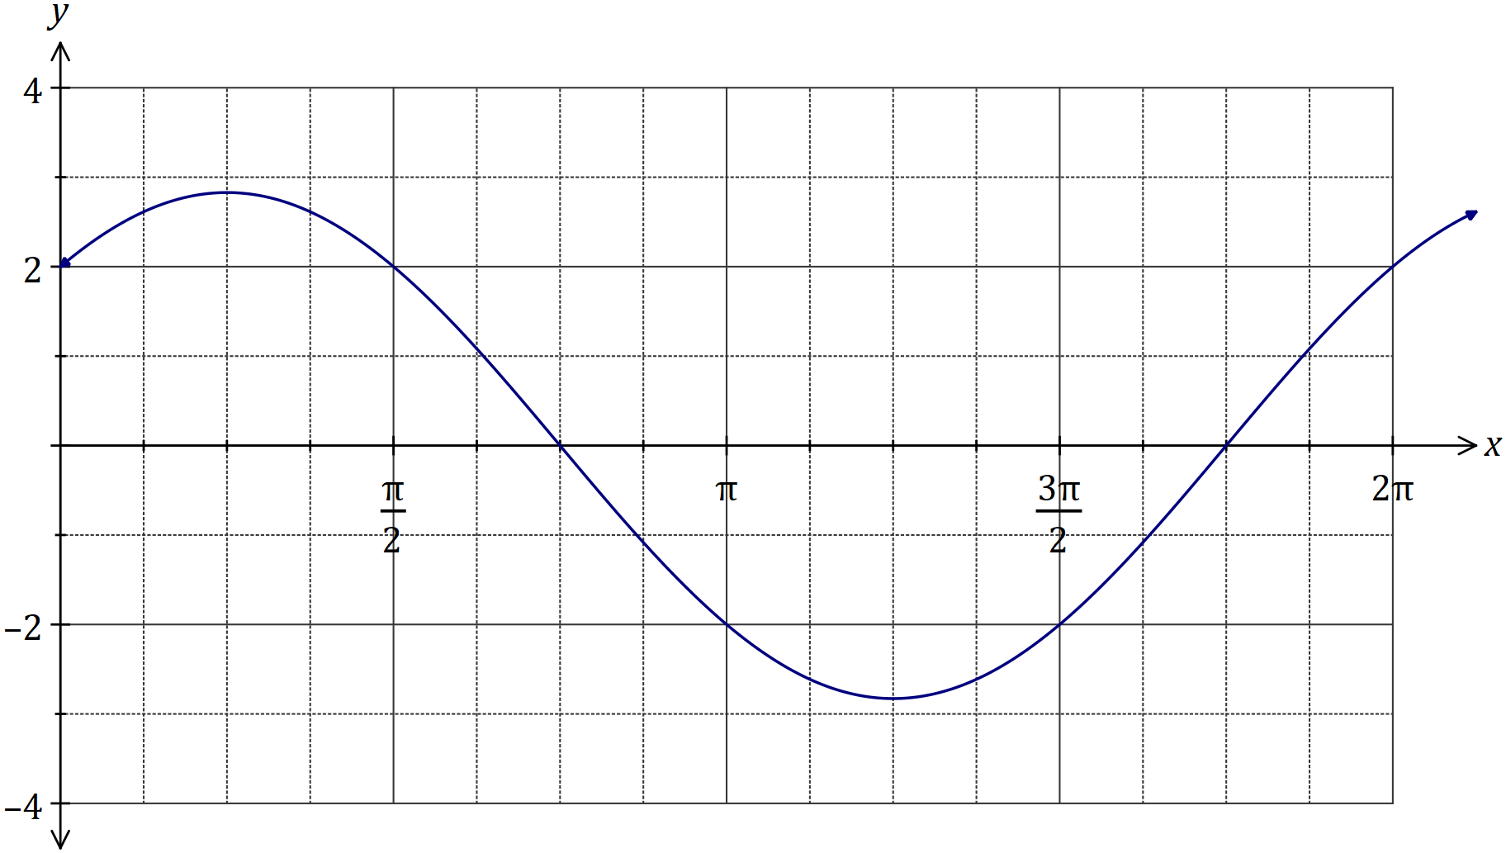
Solution
See graph
Specific behaviours
$y$-intercept
✓ roots
✓ maximum and minimum
✓ smooth sinusoidal curve

Question 7 (5 marks)
Let $OAPB$ be a parallelogram where $\vec{OA}=a$ and $\vec{OB}=b$.

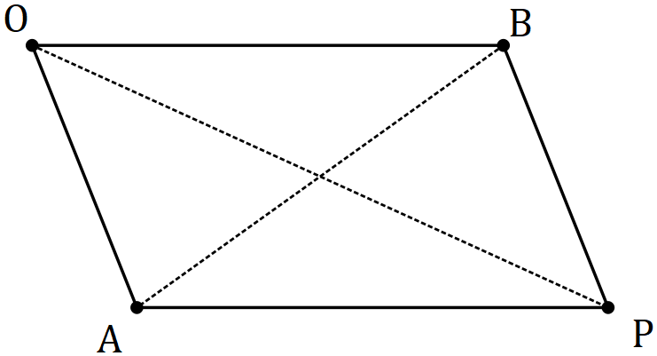

Use a vector method to prove that the sum of the squares of the lengths of the diagonals of a parallelogram is equal to the sum of the squares of the lengths of the sides.
Solution
$$\text{RTP}:{\left|OP\right|}^{2}+{\left|BA\right|}^{2}={\left|OA\right|}^{2}+{\left|OB\right|}^{2}+{\left|BP\right|}^{2}+{\left|AP\right|}^{2}$$
$$\text{Note}:{\left|r\right|}^{2}=r∙r$$

$$LHS={\left|OP\right|}^{2}+{\left|BA\right|}^{2} \\ ={\left|a+b\right|}^{2}+{\left|a-b\right|}^{2} \\ =\left(a+b\right)∙\left(a+b\right)+\left(a-b\right)∙\left(a-b\right) \\ = a∙a+a∙b+b∙a+b∙b+a∙a-a∙b-b∙a+b∙b \\ ={\left|a\right|}^{2}+{\left|b\right|}^{2}+{\left|a\right|}^{2}+{\left|b\right|}^{2} \\ ={\left|OA\right|}^{2}+{\left|OB\right|}^{2}+{\left|BP\right|}^{2}+{\left|AP\right|}^{2} \\ =RHS$$

Specific behaviours
expresses $\left|OP\right|$ and $\left|BA\right|$ in terms of $a$ and $b$
✓ uses scalar product to expand sums and differences
✓ simplifies scalar products as magnitudes
✓ expresses in terms of sides
✓ logical presentation of proof

Question 8 (8 marks)
(a) Determine all complex solutions to the equation $z^{2}-2z+5=0$. (3 marks)
Solution
$${\left(z-1\right)}^{2}-1=-5$$

$${\left(z-1\right)}^{2}=4i^{2} \\ z-1=±2i$$

$$z=1+2i, z=1-2i$$

Specific behaviours
completes square
✓ simplifies square roots of both sides
✓ states both solutions

(b) Determine the values of the positive real constants $p$ and $q$ so that $p-2i$ is a solution to the equation $2z^{2}-qz+26=0$. (5 marks)
Solution
$$2{\left(p-2i\right)}^{2}-q\left(p-2i\right)+26=0 \\ 2\left(p^{2}-4pi-4\right)-pq+2qi+26=0$$

$$2p^{2}-8pi-8-pq+2qi+26=0 \\ 2p^{2}-pq+18+\left(2q-8p\right)i=0$$

$$\operatorname{Im}{:} 2q-8p=0⇒q=4p$$

$$\operatorname{Re}{:} 2p^{2}-4p^{2}+18=0⇒p^{2}=9$$

$$p>0⇒p=3, q=12$$

Specific behaviours
substitutes, expanding square
✓ fully expands and simplifies
✓ uses imaginary terms to express $q$ in terms of $p$
✓ uses real terms to determine $p^{2}$
✓ states values

Supplementary page

Question number: _________

© 2018 WA Exam Papers. Baldivis Secondary College has a non-exclusive licence to copy and communicate this document for non-commercial, educational use within the school. No other copying, communication or use is permitted without the express written permission of WA Exam Papers. SN261-121-2.

